**Задание по поиску – 4110-2-Класс**

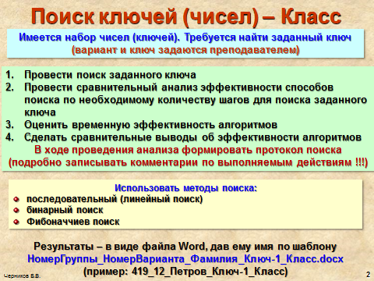

|  |  |
| --- | --- |
| **Вариант** | **Заданный набор ключей** |
| **2-01** | 4,6,7,9,10,10,12,14,15,17,19,21,24,25,26,26,28,34,35,38,41,46,48 |
| **2-02** | 5,6,7,9,10,13,15,16,18,19,19,26,26,27,27,29,29,35,36,36,38,45,49 |
| **2-03** | 1,2,7,8,12,15,17,17,19,27,27,29,36,39,42,42,47,57,59,63,64,68,73 |
| **2-04** | 5,6,9,10,14,15,17,19,22,24,26,28,33,33,42,42,47,47,58,59,61,68 |
| **2-05** | 13,15,16,16,19,22,23,25,26,28,35,37,41,41,47,47,48,49,71,78,83 |
| **2-06** | 6,6,8,9,16,19,19,21,26,27,28,35,35,48,48,51,53,59,67,72,78,83,84 |
| **2-07** | 2,23,23,36,38,42,47,53,56,69,69,73,73,78,78,82,82,84,89,91,93 |
| **2-08** | 4,6,8,9,11,11,14,16,17,18,20,20,21,23,24,26,26,33,36,38,39,42,47 |
| **2-09** | 2,4,6,8,11,12,12,14,15,17,18,20,21,21,24,26,28,31,34,37,39,39 |
| **2-10** | 2,3,4,7,8,9,11,15,22,22,27,31,31,36,36,42,46,48,49,60,60,68,79 |
| **2-11** | 2,5,8,9,9,12,12,16,18,23,26,29,31,36,38,45,58,89,93,95,98,100 |
| **2-12** | 7,8,12,16,19,21,21,27,34,34,39,40,42,46,48,48,53,54,54,57,59,70 |